Siddhesh Nisal
Phone: +91- 7499427345  Puraniks Aldea, Baner-Mahalunge Rd,  Pune - 411045 | Email  siddheshnisal@gmail.com
Objective | Apply my subjective and objective knowledge, which could help in growth of organization as well as my personal growth.
Skills & Abilities | Primary : -Oracle HCM Cloud – Performance & Goals Management, Absence Management, Compensation, Workforce Compensation, Customization and Personalization, BI reports, OTBI, HCM Data Loader, Security, Alert Composer, Workflow notifications, HCM Configurations, Fast Formula, SQL, Redwood UI, VBCS,REST API,Oracle Gen AI.  Secondary: Help Desk, ORC, OLC, HCM Extracts, HSDL, PeopleSoft application engine, PSQuery, SQR, PeopleSoft HCM 9.2 ,PL/SQL, Javascript, WinSVp, Manual Testing
Experience | Tata Consultancy Services Jan 2022– Current  Oracle HCM Developer, Client – Colonial First State, Australia  - Working in enhancement area where my role is to develop new BI reports, customize existing reports.  - Possesses good knowledge in BI, OTBI reports, SQL, worked on many HCM enhancements so far.  - Worked on many customizations using tools like Page composer, HCM Transaction design studio, Alert Composer, Fast Formula, Workflow notifications.  - Working in modules like Performance management, Compensation, Workforce compensation, Absence management, Core HR, ORC, OLC, Redwood transitions.  - Working in sprint wise development, involved in activities like creating TDDs and unit test case documents.  - Providing UAT and on call technical support to business users.  - Received many customer appreciations for providing high quality results within quick time.  Tech Mahindra – Aug 2021 – Jan 2022  Tech lead- Developer, Client – Bell Corp, Canada.  - Worked in CRM development project of PeopleSoft.  - Worked on complex application engine, Integration broker & APIs.  - Worked on JSON document creation, Fusion HCM Configurations.  Zensar Technologies – Sept 2019 – Aug 2021  Sr.Software Engineer – PeopleSoft Developer, Client – BMI Healthcare, UK  - Involved in PeopleSoft development activities like creation of new application engines, PSQueies, complex SQLs for reports.  - Provided on call technical support around UAT and unit testing.  - Worked on Component Interface, ExceltoCI, Integration broker.  Provided functional support.  Cognizant Technologies – Sept 2018 – Sept 2019  Associate – PeopleSoft Developer, Client – ESA, Cognizant  - Worked in resource management area, involved in activities like customizing existing functionalities  Created and modified application engines as per business requirement, worked on PSQueries.  Hexaware Technologies – Apr 2015 – Aug 2018  Software Engineer – Peoplesoft developer Client – General Electric, USA  - Worked in Pension Administration area, created PSqueries, Views  - Worked on Leave ,management system  - Created SMTP mail sending functionality, configured new leave system for Latvia while working for client.
Education | Indira College of Engineering – Pune – BE(IT)  Jun 2010 – May 2014  Percentage – 58.26%  Sau.Venutai Chavan Polytechnic – Pune – Diploma (IT)  Jun 2006 – May 2010  Pecentage – 70.53%  M.E.S Renavikar Vidyalaya, - Ahmednagar – SSC  Jun 2005 – May 2006  Percentage – 71.20%
Awards and recognitions | Best Team Award – TCS – Dec 2024  Best Individual contributor (projects) – Oct 2023  Completed many Udemy courses of Redwood, Oracle Fusion HCM.  Completed SEED automation certification course in 2014 with A+ grade.
Certifications | Oracle Global Human Resources 2024, Oracle Redwood certified application professional 2023, Oracle Digital Assistant professional 2023, Oracle Integration Cloud certified professional 2023, Oracle HCM Business process R 2
  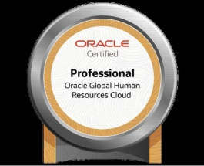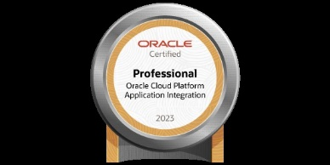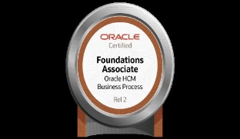
Strengths | Adaptive, Self-learner, Self-motivated, dedication towards work.
Hobbies | Reading books, novels & newspapers.  Quizzing, listening music,  Continuously learning advance concept in Oracle University.

